C PROGRAMMING
NAME : YOKITHA S
ROLL NO: 242801327
WEEK 15
TOPIC : POINTERS
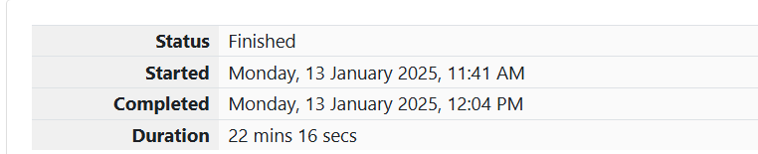

1. Problem Statement: Reverse a List
Given a list of integers, write a program to reverse the list.
Function Description
Complete the function reverseList with the following parameter:
- int arr[n]: an array of integers.
Returns
- An array of integers in reverse order.
Constraints
- 1≤n≤1051 \leq n \leq 10^51≤n≤105
- −104≤arr[i]≤104-10^4 \leq \text{arr}[i] \leq 10^4−104≤arr[i]≤104
Sample Input
Copy code
5
1 2 3 4 5
Sample Output
Copy code
5 4 3 2 1

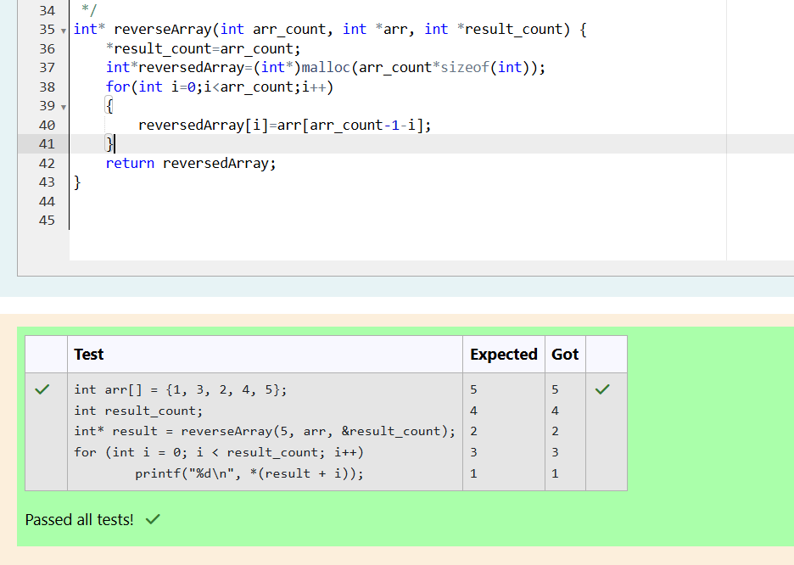

2.

Problem Statement: Maximize the Value
You are given a list of integers. Write a program to maximize the value of the product of two elements from the list. The result should be the maximum product achievable by multiplying any two elements.
Function Description
Complete the function maxProduct with the following parameter:
- int arr[n]: an array of integers.
Returns
- An integer representing the maximum product.
Constraints
- 2≤n≤1052 \leq n \leq 10^52≤n≤105
- −104≤arr[i]≤104-10^4 \leq \text{arr}[i] \leq 10^4−104≤arr[i]≤104
Sample Input
Copy code
5
1 2 3 4 5
Sample Output
Copy code
20

